**LEBANESE AMERICAN UNIVERSITY**

**USAID – HIGHER EDUCATION SCHOLARSHIP PROGRAM**

**HES - Volunteering Program Verification Form**

This form is to be used to document volunteering hours. If a student volunteers for multiple organizations, a separate form must be used for each organization. **This form must be turned in by the 28th of each month, the latest.**

I certify that the scholar Hiba Issa completed a total of 5 hours of service at InnovaThrive.

The hours were completed hours as per the below:

Hours # 0 (date) _2/12 – 6/12_ (initials of supervisor) __A.K.___

Hours # 0 (date) _9/12 – 13/12_ (initials of supervisor) __A.K.___

Hours # 5 date) _16/12 – 20/12 (initials of supervisor) __A.K.___

Hours # 0 date) _23/12 - 27/12 (initials of supervisor) __A.K.___

Brief description of the activities the scholar performed or participated in:

Research on AI in Combatting Financial Fraud and Money Laundering  
  
My research focused on the role of AI in detecting and preventing financial fraud and money laundering. AI technologies, particularly machine learning algorithms, are increasingly being used by financial institutions to analyze vast amounts of transaction data in real-time, identifying suspicious patterns and behaviors that may indicate fraudulent activities or money laundering schemes.  
  
I explored key applications such as AI-powered fraud detection systems, predictive analytics for risk assessment, and the use of natural language processing (NLP) to detect anomalies in financial documents. Real-life examples showed how AI has helped reduce fraud by automatically flagging suspicious transactions for further investigation.  
  
The advantages of using AI in this context include faster detection, reduced false positives, and more efficient compliance with regulations. However, challenges like data privacy concerns, the need for continuous algorithm updates, and the potential for AI biases were also discussed.  
  
Finally, my research suggested future directions for AI in this area, including the development of more sophisticated models to adapt to evolving fraud techniques and enhancing collaboration between AI systems and human experts to improve accuracy and decision-making.

Written feedback about the scholar’s performance:

Hiba’s research on AI in financial fraud detection was insightful, highlighting AI’s role in identifying fraud and money laundering. She discussed both the advantages of faster detection and challenges like data privacy concerns.

Please rate the overall performance of the scholar at your organization:

|  |  |  |  |
| --- | --- | --- | --- |
|  | Mastery (5) | Proficient (3) | Emerging (1) |
| **Problem solver** | X |  |  |
| **Engaged & Committed** | X |  |  |
| **Open-minded & multicultural** | X |  |  |

Signature

& stamp

__________________________

_

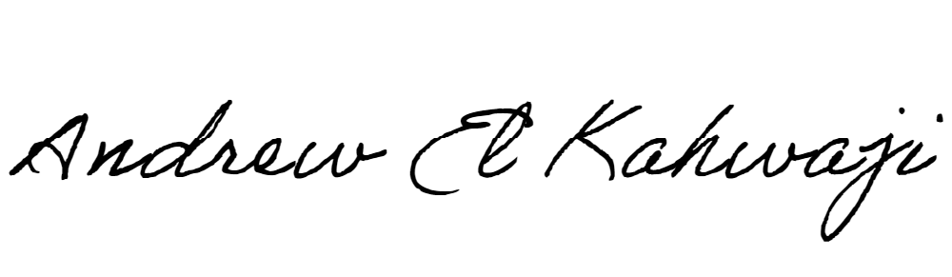

Printed Name _Andrew El Kahwaji_

Date __26/12/2024___

Email __andrew.lifesculptor.coo@gmail.com __

Phone __+961 71 914 378__